**FOOD RECORD COLLECTION FOR DIETARY ANALYSIS**

**TIPS AND SAMPLE FOOD RECORD FORM**

Recall form formatting:

* If participants are keeping a paper and pencil record form, make sure the spaces are large enough for people to write comfortably and clearly—not too small that writing is cramped.
* You may consider adding numbers to each line in the record form for reference purposes

Participant instructions:

* Encourage participants to record the food as they are eating it.
* Participants should record something in each column—a food name, a description, and the amount with the unit.
* You will need to provide details to the participants regarding what type of description and preparation detail they need to provide for various types of food. NDSR facilitates very detailed data entry which participants may not think of without being told. If there are specific foods or nutrients of interest for your particular study, be sure to include instructions related to those foods/nutrients. Here are just a few examples:
  + Beverages:
    - Soda—was it diet or regular?
    - Milk—what percent fat was it? If non-dairy milk, what type, and was it sweetened or unsweetened?
  + Vegetables:
    - Were they cooked or eaten fresh/raw?
    - If cooked, how were they cooked? What type of butter, oil, or margarine were added, if any? Was salt added?
  + Meat:
    - Was the meat breaded, and if so, what type of breading?
    - Was there skin or visible fat eaten, or was it removed?
    - What type of butter, oil, or margarine were used in cooking, if any? Was salt added?
* It can be helpful to provide the participant with a sample completed food record form.

**<Study Name Here>**

**Sample Food Record Form**

**Participant ID:** _________________________________________________

**<Instructions for which day(s) to record here, if needed> :**

**_________________________________________________________________________________________________________________________**

**_________________________________________________________________________________________________________________________**

**<Any other relevant instructions here, such as next step instructions (i.e. Return this form to/Bring this with you for your next visit on)>:**

**_________________________________________________________________________________________________________________________**

**_________________________________________________________________________________________________________________________**

Questions: Call <contact name here> at XXX-XXX-XXXX

**INSTRUCTIONS FOR RECORDING FOODS, BEVERAGES & SUPPLEMENTS**

1. Use brand names whenever possible. **For example: ¼ cup Bumble Bee tuna, packed in water.**
2. Remember to list all additions to foods and beverages, such as cream, sugar, butter, jelly, lemon, salad dressing, artificial sweeteners, catsup, etc. Don’t forget ingredients added in food preparation and/or at the table, such as soy sauce, oils, other types of fat, and salt.
3. Describe how foods are prepared. **For example: ½ cup frozen broccoli, steamed.**
4. Use measuring cups or spoons whenever possible. **For example: 1 tsp. Sugar; 1 ½ cups Campbell’s cream of tomato soup.**
5. For beverages, indicate if you had ice in the beverage and you may use fluid ounces instead of cups. **For example: 12 fl oz Pepsi, no ice.**
6. For foods that do not fit in a cup or spoon, use dimensions. **For example: 1 corn tortilla, 6 inches across; 1 piece of cheddar cheese 3”x2”x1”; 1 banana nut muffin 2”x1”.** There is a ruler printed on the back page of this booklet to help with measuring foods.
7. For whole pieces of fruit or vegetables, you may use small, medium, or large. **For example: 1 small apple.**
8. List each food item, and the amount of each item, in mixed dishes. **For example: 1 cup leaf lettuce, 6 cherry tomatoes, ¼ cup diced cucumber.**

**Food Record Form**

**Participant ID:** _________________________________

**Date of Recording:** ______/______/______

Month Day Year

|  |  |  |  |
| --- | --- | --- | --- |
| **Time of day** | **Food and beverage description**  (e.g. skim milk, Honey Nut Cheerios, McDonalds French fries) | **Preparation** (e.g. Fried, steamed, or other cooking method? Was butter, oil, margarine used in cooking? Salt added?) | **Amount eaten and unit**  (e.g. 1 cup, 2 pieces) |
|  |  |  |  |
|  |  |  |  |
|  |  |  |  |
|  |  |  |  |

|  |  |  |  |
| --- | --- | --- | --- |
| **Time of day** | **Food and beverage description**  (e.g. skim milk, Honey Nut Cheerios, McDonalds French fries) | **Preparation** (e.g. Fried, steamed, or other cooking method? Was butter, oil, margarine used in cooking? Salt added?) | **Amount eaten and unit**  (e.g. 1 cup, 2 pieces) |
|  |  |  |  |
|  |  |  |  |
|  |  |  |  |
|  |  |  |  |
|  |  |  |  |
|  |  |  |  |
| **Time of day** | **Food and beverage description**  (e.g. skim milk, Honey Nut Cheerios, McDonalds French fries) | **Preparation** (e.g. Fried, steamed, or other cooking method? Was butter, oil, margarine used in cooking? Salt added?) | **Amount eaten and unit**  (e.g. 1 cup, 2 pieces) |
|  |  |  |  |
|  |  |  |  |
|  |  |  |  |
|  |  |  |  |
|  |  |  |  |
|  |  |  |  |
| **Time of day** | **Food and beverage description**  (e.g. skim milk, Honey Nut Cheerios, McDonalds French fries) | **Preparation** (e.g. Fried, steamed, or other cooking method? Was butter, oil, margarine used in cooking? Salt added?) | **Amount eaten and unit**  (e.g. 1 cup, 2 pieces) |
|  |  |  |  |
|  |  |  |  |
|  |  |  |  |
|  |  |  |  |
|  |  |  |  |
|  |  |  |  |

**FOOD LABELS**

Pay attention to food labels when keeping your food record. Food labels contain a Nutrition Facts label with product specific information, including serving size and number of servings. **The serving size and number of servings per container can help you report the amount of food you ate.** In the sample label, one serving is 2/3 cup (55g). If you ate 3 servings, you would report that you ate 2 cups, or ‘3 servings, 2/3 cup each’.

Sample label:

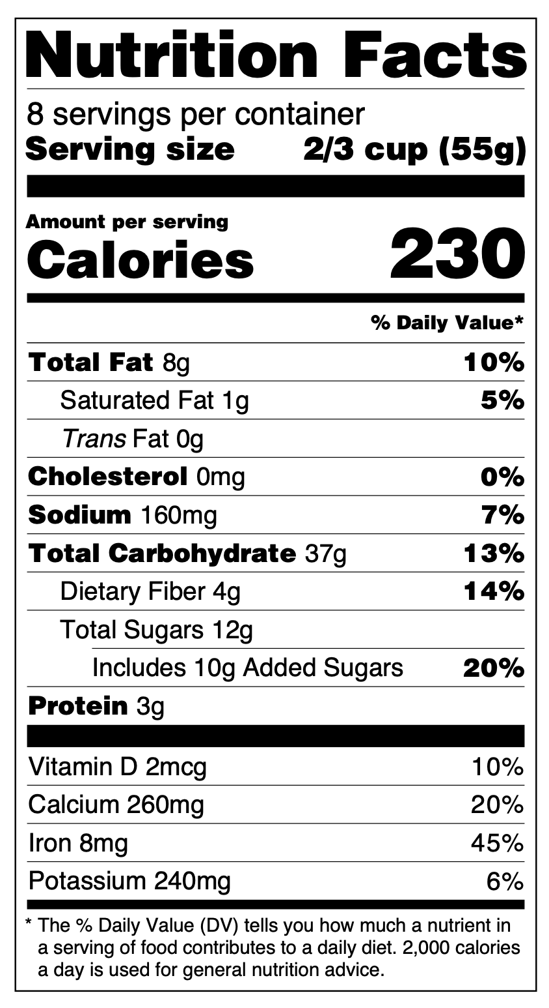

**MEASUREMENT AID**

You can use the ruler printed on the side of this page to measure the dimensions of foods to help you report the amount. For a pancake or a cookie, measure the diameter, shown by the dotted line.

For foods like a slice of cheese or cake, measure the length, width, and height, shown by the dotted lines.

For a triangle shaped piece of pizza or pie, measure the length of the piece (the radius) and the width of the piece. For cheese or cake, measure the length and width, as well as the height.

Sample entry:

Homemade chocolate chip cookie, 1 cookie, 4” diameter

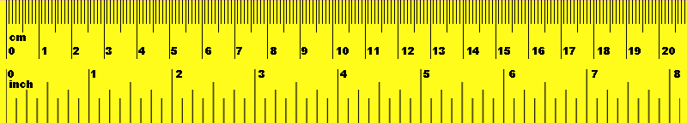

Sample entry:

Cheddar cheese, 4 pieces, 2” x 2” x 1/8”

Length/radius

Width

Height

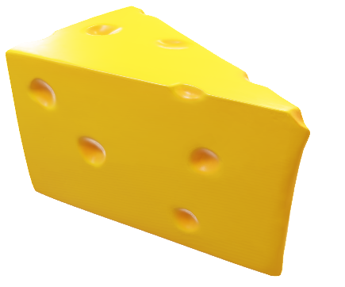

Sample entry:

Pepperoni pizza, from Pizza Hut, thin crust, 1 piece, 8” length, 4” width

Packet developed using materials from the University of Arizona Nutritional Assessment Laboratory, Dept. of Nutritional Sciences, BEST Study